Agricultural Revolution:
Five factors of the Agricultural Revolution
1. _______________ Movement
# Small _________ made into one big farm
# New owners ______________ with new techniques
# Small farmers forced to move and
find work in the _________
2. Crop ________________
#Made use of ALL ________ ALL the________ with fertilizing crop.
Example: First plant wheat, which soaks up nutrients.
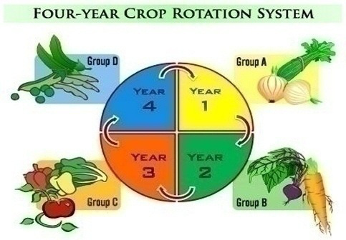
Then plant turnips which restores nutrients
3. Seed Drill Inventor = ________________ Seed drill planted seeds efficiently. Seeds planted in well-spaced rows and depths = more crops!
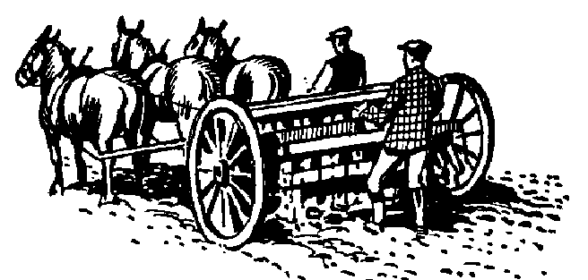
4. Breeding Animals
# Robert Bakewell’sidea
# Allowed only his best sheep to breed
# Bigger animals = more meat!
5. New crops = corn and potatoes
Agricultural Revolution:
Five factors of the Agricultural Revolution
1. _______________ Movement
# Small _________ made into one big farm
# New owners ______________ with new techniques
# Small farmers forced to move and
find work in the _________
2. Crop ________________
#Made use of ALL ________ ALL the________ with fertilizing crop.
Example: First plant wheat, which soaks up nutrients.
Then plant turnips which restores nutrients
3. Seed Drill Inventor = ________________ Seed drill planted seeds efficiently. Seeds planted in well-spaced rows and depths = more crops!
4. Breeding Animals
# Robert Bakewell’sidea
# Allowed only his best sheep to breed
# Bigger animals = more meat!
5. New crops = corn and potatoes

