Section 11 - Miguel Cervantes, Spanish Writer
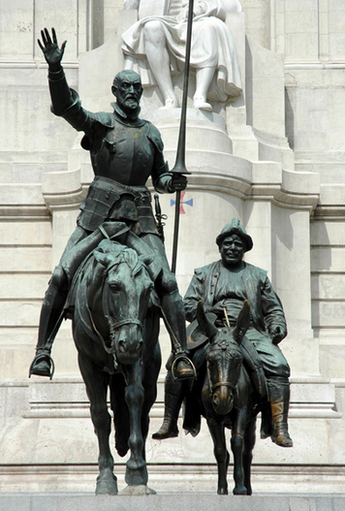
Miguel Cervantes (mi-GEL ser-VAN-tayz) was born near Madrid, Spain. He lived from 1547 to 1616. He is best known for his comic novel Don Quixote (DON kee-HOH-tay).
Personality and Training Little is known about Cervantes’ education. He may have studied with priests influenced by humanism. It is certain that he loved to read.
Much of Cervantes’ education came through experience. At 23, he became a soldier. In a battle at sea, he was shot twice in the chest. He also injured his left hand so badly that the hand became useless. Several years later, he was taken prisoner at sea by pirates. He spent five years as a slave in North Africa until his family bought his freedom.
Cervantes’ early life shows that he was adventurous and courageous. His sense of humor could be biting, but he also turned it on himself. He once bragged that the public liked his plays enough not to boo them off the stage or throw vegetables at the actors.
Talents and Achievements A gifted writer, Cervantes wrote many plays, poems, and novels. He had a particular talent for satire. His masterpiece, Don Quixote, pokes fun at romantic stories of heroic knights, as well as at Spanish society. The novel’s title character, Don Quixote, is an elderly man who has read too many tales of glorious knights. Although the age of knights is past, he dresses up in rusty armor and sets out to do noble deeds. With him is short, stout Sancho Panza. Sancho is an ordinary farmer who rides a mule, but Don Quixote sees him as his faithful squire, or armor bearer.
Together the two men have a series of comic adventures. In Don Quixote’s imagination, country inns turn into castles and windmills become fearsome giants. While his adventures are very funny, there is something noble about the way he bravely fights evil, even if his deeds are only in his mind.
Don Quixote was very popular in Spain. King Philip III supposedly saw a man reading and laughing so hard that he was crying. The king said, “That man is either crazy or he is reading Don Quixote.” Today, Don Quixote is considered one of the masterpieces of world literature

