Leading figures of the Renaissance

1. Introduction
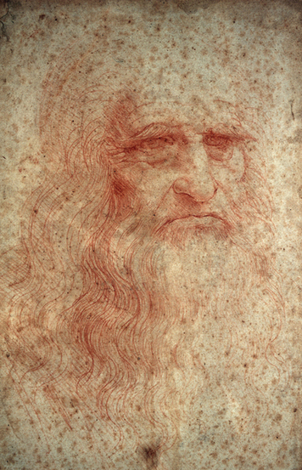
The period in Europe known as the Renaissance began in Italy around 1300. In this chapter you will learn how Renaissance ideas spread from Italy across Europe. You will study the lives and work of ten leading figures of this rich cultural period.
From the 14th through the 16th centuries, Europe crackled with energy. Trade and commerce boomed. Cities grew. Artists and writers experimented with their crafts and created wonderful works of art and literature. New ways of thinking led to inventions and scientific discoveries. Rulers and wealthy patrons supported the work of artists, scientists, and explorers.
Why was there so much creative energy during the Renaissance? One reason was the Renaissance idea that people should be educated in many areas. People who studied art or music, for example, were also interested in science. To this day we still use the term “Renaissance person” to describe someone who is skilled and knowledgeable in many fields.
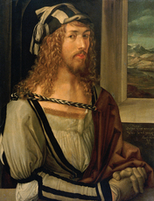
Leonardo da Vinci is often considered to be the ideal Renaissance person. Leonardo trained mainly as a painter, but he was also a scientist, engineer, musician, and architect. He designed fortifications, waterways, and machines. He studied and drew plants, animals, and people. In his notebooks, he sketched ideas for inventions that were far ahead of his time.
Leonardo is one of the ten Renaissance people you will study in this chapter. You will learn how contributions made by these leading figures affect society today. You will also learn how the Renaissance spread from its birthplace in Italy throughout Europe.

2. The Renaissance Spreads Through Europe
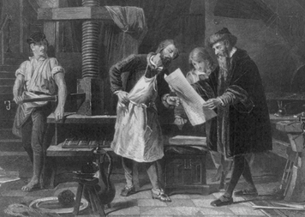
As you have read, the Renaissance began in Italy. From there it spread to France, Germany, Flanders (modern-day Belgium), Holland, England, and Spain.
The diffusion of Renaissance ideas occurred through trade, travel, and education. Italy was the gateway to Europe for much of the trade from Asia, Africa, and the Greek-speaking cities of the east. Traders moved through Italy to the rest of Europe, bringing a rich flow of new ideas along with their goods.
Visitors to Italy also helped spread Renaissance ideas. People from all over Europe traveled to Italy to learn, as well as to trade. Scholars went to study humanism and medicine. Artists studied Italian painting and sculpture to learn new styles and techniques.
When these travelers returned home, many of them founded art schools and universities. Artists taught others what they had learned in Italy. Scholars began to teach the new ideas of experimentation, observation, and logic.
The spread of ideas was made even easier by the invention of the printing press. This machine pressed inked type or plates onto paper to create many copies of a work. You may recall that the Chinese had learned to make paper and to print using wooden blocks. The Koreans had invented a kind of movable type. Gradually, knowledge of papermaking and examples of Asian printing reached Europe.
In about 1450, a German named Johannes Gutenberg dramatically improved on existing printing methods. He invented a printing press that used movable type—characters that could be rearranged and used over again. Unlike the Chinese, who used wooden blocks, Gutenberg cast his type in metal, which was much more durable.
Before Gutenberg’s invention, most books were written and copied by hand. It could take four or five months to copy a 200-page book. The new press could produce 300 pages in a single day. As a result, books and short works, called pamphlets, could be made much more quickly and cheaply.
The number of printers in Europe increased rapidly. People used printed matter to communicate new ideas, discoveries, and inventions. And, since printed material was more widely available, more people learned to read.

3. Michelangelo, Italian Sculptor and Painter
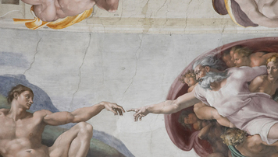
Michelangelo (1475–1564) was one of the leading artists of the Renaissance. He was born in a small village near Florence and grew up to be one of the greatest painters and sculptors in history.
Personality and Training Historians say that Michelangelo had a difficult childhood. His mother died when he was six years old. His father was stern and demanding. Perhaps this troubled early life contributed to Michelangelo’s famously bad temper. Although he was very religious, he was known to use fierce words when he was angry. He was also intensely ambitious.
When Michelangelo was 13, he became an apprentice to a painter in Florence. At 15, he began studying with a sculptor who worked for the powerful Medici family. Michelangelo lived for a time in the Medici household. There he met many leading thinkers, artists, and writers.

Talents and Achievements Michelangelo was gifted in both sculpture and painting. His art combines Renaissance ideals of beauty with emotional expressiveness.
Michelangelo’s sculptures show his amazing talent for carving lifelike figures from blocks of marble. When he was just 24, he carved his famous La Pietà. A pietà is a depiction of Mary, the mother of Jesus, mourning over her dead son. Michelangelo’s Pietà shows Mary tenderly holding the body of Jesus across her lap.
Two other magnificent sculptures by Michelangelo are his David and Moses. Michelangelo’s David is 17 feet tall. The statue combines great beauty with the intense look of a youth who is about to go into battle. Michelangelo’s Moses is a strong, powerful figure. The statue shows Moses holding the Ten Commandments, which the Bible tells he received from God.
Michelangelo is perhaps best known for painting the ceiling of the Sistine Chapel, the pope’s chapel in Rome. Michelangelo labored for almost four years on a high platform to complete this work. He covered the curved ceiling with brilliantly colored scenes from the Bible. The scenes contain over three hundred figures and continue to awe visitors to Rome today.

4. Titian, Italian Painter
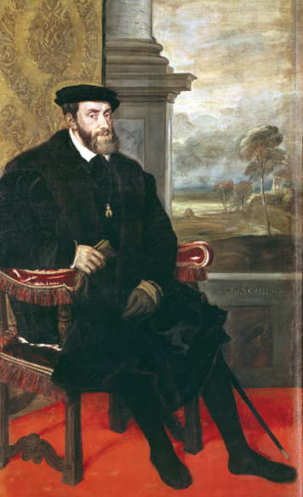
Titian (TISH-uhn), who lived from about 1488 to 1576, was born in the Italian Alps. Early in life, his talent took him to the wealthy city-state of Venice. He became the city’s greatest Renaissance painter.
Personality and Training As a boy, Titian was sent to Venice to train with famous painters. He worked with an artist named Giorgione, who was a master of fresco painting. A fresco is a painting made on the wet plaster of a wall or ceiling. Titian also studied examples of art from Rome and Florence. In time, he outgrew the influence of his teachers and created his own style.
Titian was a persuasive man. According to legend, long after he was rich and famous, he persuaded patrons to support his art by claiming to be poor. But he was also quite generous with his friends.
Talents and Achievements Titian’s early work was precise and detailed. Later he developed a freer style. He used blobs of paint to create vivid forms, colors, and textures. He was known for his inspired use of color and for loose, lively brushwork that made his pictures appear lifelike. His art also had a flair for expressing human personality.
Titian painted many scenes of classical myths and Bible stories. As a court painter, he created portraits of the rich and powerful. In 1516, he was named the official painter of Venice. Later, Holy Roman emperor Charles V made him court painter of Italy. Titian made many portraits of Charles V and other royalty.
Charles V greatly admired Titian’s work. There is a story that the emperor once picked up a paintbrush that had fallen to the floor. Titian protested, “I am not worthy of such a servant.” The emperor replied, “Titian is worthy to be served by Caesar,” referring to the emperor of ancient Rome. Charles even made Titian a knight—a first-time honor for a painter.

5. Albrecht Dürer, German Artist
Albrecht Dürer (AHL-brekht DOOR-er), who lived from 1471 to 1528, was from the German city of Nuremberg. He earned fame for his paintings, drawings, prints, and essays about art.
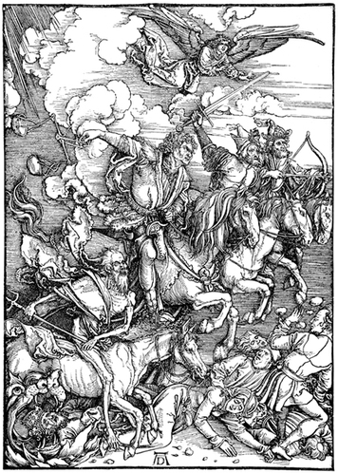
Personality and Training As a boy, Dürer received a diverse education. The son of a goldsmith, he learned his father’s trade. At 15, he began training with a well-known painter and printmaker. A printmaker uses printing to make copies of works of art. Dürer also studied math, Latin, and classical literature.
As a young man, Dürer traveled through Germany, Italy, and the Netherlands. He became friends with many humanist artists, writers, and thinkers. He studied classical sculpture for years to learn ideal human proportions. He wanted to be able to show the parts of the human body correctly sized in relation to each other.
Dürer’s self-portraits show him to be a fashionable, confident man. He had an intellectual approach to life and art. He asked himself, “What is beauty?” His art was an attempt to answer that question.
Talents and Achievements In his painting, Dürer blended the detailed style of Germany with the perspective and idealized beauty he learned from Italian painting. He encouraged all artists to study mathematics as the key to understanding Renaissance and classical art.
Dürer was especially skilled at making engravings and woodcuts. These are prints made from an original that is specially prepared for printing. The original may be etched, or engraved, in metal or it may be cut into a block of wood. Then it is inked and re-inked to make copies. In Renaissance times, printers used engravings and woodcuts to illustrate books.
Much of Dürer’s art shows religious figures. He also painted subjects from myths. Like other artists of his time, he made many portraits of royalty and wealthy patrons. He worked for years as a court artist for the Holy Roman emperor Maximilian I.
Dürer’s work is widely admired, particularly his beautiful engravings and woodcuts. They set a new standard in print-making because of their clarity, expressiveness, and fine detail.

6. Nicolaus Copernicus, Polish Scientist
Nicolaus Copernicus (1473–1543) was born in Torun, Poland. He is often called the "father of modern astronomy."
Personality and Training When Copernicus was ten years old, his father died. His uncle, a Catholic bishop, became his guardian. He made sure that Copernicus received a good education.
As a young man, Copernicus attended the University of Krakow in Poland. Then he went to Italy to study medicine and Church law. In Italy, he rented rooms from an astronomy teacher. Soon he became fascinated by astronomy.
Copernicus’s scientific work would show that he was highly creative. He was also a free thinker, unafraid to question accepted beliefs.
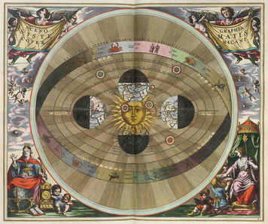
Talents and Achievements Copernicus was skilled in mathematics and observation. He based his thinking on what he truly saw, rather than on what he thought he should see.
Like other people of his time, Copernicus had been taught that Earth was at the center of the universe. According to this idea, the sun, stars, and planets travel around Earth.
As Copernicus studied the motion of the planets, he became dissatisfied with this explanation. He proposed a revolutionary idea. In reality, Earth and the other planets orbit the sun. Earth rotates, or turns, on its axis. This turning is what makes the sun and other objects in the heavens seem to move across the sky around Earth.
In 1514, Copernicus printed a booklet that outlined his theory. Then he began years of work on a full-length book. He titled it On the Revolutions of the Celestial Spheres. (Celestial means “heavenly.”)
Copernicus dedicated his book to the pope. However, the idea of Earth traveling around the sun went against the Roman Catholic Church’s belief that God had placed humans at the center of the universe. In 1616, the Church forbade people to read Copernicus’s book.
Despite the Church’s disapproval, Copernicus’s theory had a major influence on a few key scientists. Eventually, it was proved to be correct. Today, the Copernican theory is part of the basis of modern astronomy.

7. Andreas Vesalius, Belgian Scientist
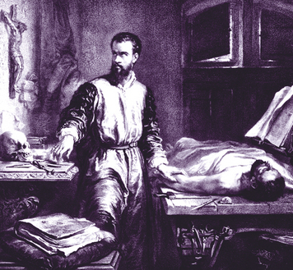
Andreas Vesalius (1514–1564) was born in Brussels, in what is now Belgium. He became an outstanding scientist. His work changed medicine and the study of anatomy.
Personality and Training Vesalius came from a family of doctors and pharmacists. Pharmacists are people who prepare medicines. He was always interested in living things and, especially, in anatomy.
Vesalius attended universities in Flanders, France, and Italy. In 1537, he earned his medical degree, specializing in anatomy. Later, he became a personal doctor to Italian and Spanish royalty.
Vesalius was hardworking, curious, and confident. He was also said to be gloomy and distant at times.
Talents and Achievements Vesalius was a talented observer and an independent thinker. He also had the artistic skill necessary to make detailed drawings of his scientific observations.
In Vesalius’s time, physicians’ understanding of human anatomy was based on the works of the ancient Greek physician Galen. Vesalius studied Galen, but he soon broke with this tradition. Like Copernicus, he was determined to observe things for himself.
Vesalius began dissecting, or cutting apart to study, dead human bodies. His research showed that Galen’s work had relied on studies of animals. As a result, it had many errors when applied to human anatomy and medicine.
Vesalius made many discoveries about the human body. For example, he showed that the human heart has four hollow areas, called chambers. His discoveries led him to write his own seven-volume textbook of anatomy.
Vesalius called his book On the Structure of the Human Body. It explains how the body functions. The book contains prints by artists that were based on Vesalius’s drawings of the body.
Vesalius’s book was a major breakthrough. It changed what people knew about human anatomy and how they studied it. It also changed physicians’ understanding of medicine. His book is considered to be the world’s first modern medical textbook.

8. Isabella I, Queen of Spain
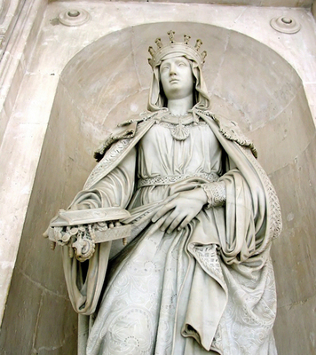
Queen Isabella I (1451–1504) was born in the Spanish kingdom of Castile. She is best known for creating a unified Spain and for sponsoring the voyages of Christopher Columbus.
Personality and Training Isabella was the daughter of the king of Castile. She was highly intelligent, strong-willed, and a devoted Catholic. Girls at that time received little education, so Isabella’s schooling was limited. In adulthood, she educated herself by learning Latin. As queen, she supported scholarship and art, collected fine paintings, and built schools.
Talents and Achievements Isabella was a forceful and brave ruler. In 1469, she married Prince Ferdinand of Aragon, the other major kingdom in Spain at that time. In 1474, Isabella became queen of Castile. When Ferdinand inherited the throne of Aragon in 1479, the two monarchs ruled jointly over much of Spain. They fought several battles to unify the rest of the nation.
Isabella and Ferdinand actively encouraged exploration. Isabella gave her support to Christopher Columbus, an Italian who proposed finding a new sea route to Asia. In 1492, Columbus sailed across the Atlantic and stumbled upon the Americas. His discovery of this so-called New World would lead to a Spanish empire and create great wealth for Spain.
Isabella and Ferdinand also sought to strengthen Spain as a unified Catholic country. Jews who refused to convert to Catholicism were forced to leave. This harsh action cost Spain many of its most talented and productive citizens. For Spanish Jews, it was a tragedy.

9. Elizabeth I, Queen of England
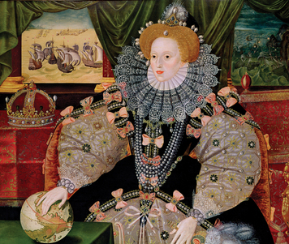
Queen Elizabeth I (1533–1603) was one of England’s most popular and successful monarchs. Born in London, she was the daughter of King Henry VIII and his queen at the time, Anne Boleyn.
Personality and Training When Elizabeth was two years old, King Henry lost interest in Queen Anne. Claiming that Anne had been unfaithful to him, he ordered her beheading.
Elizabeth was raised in a separate household, largely away from the royal court. An English scholar became her teacher and educated her as a possible future monarch. Elizabeth was a gifted student. She became highly educated and learned to speak Greek, Latin, French, and Italian.
Elizabeth was a strong-minded ruler, but she was not stubborn. As monarch, she was willing to listen to good advice and always kept in mind what was best for the people of England.
Talents and Achievements Elizabeth became queen at age 25 and reigned for 45 years, until her death. She never married, because she feared that a husband would take her power. She said she was married to the people of England.
Elizabeth was a hard-working and able ruler. She was independent, but she was also flexible. She was willing to change unpopular policies. She showed political skill in balancing the interests of different people in her court. She inspired great love and loyalty from her subjects, who called her “Good Queen Bess.”
Elizabeth’s long reign is often called England’s Golden Age. Culture thrived under her rule. She supported theater, fashion, literature, dance, and education. Poets and playwrights during her rule composed some of the greatest works in the English language.
Elizabeth worked to strengthen England’s economy, and she encouraged trade and commerce. She authorized English trading companies in Africa, Asia, and the Americas. Her funding of sea exploration helped England gain territory in North America. In 1588, the English navy defeated the Spanish Armada, a mighty fleet that tried to attack England. This victory sparked a national celebration and further strengthened England’s sea power. By the time Elizabeth died, England was one of the strongest and richest countries in the world.

Section 10 - William Shakespeare, English Poet and Playwright
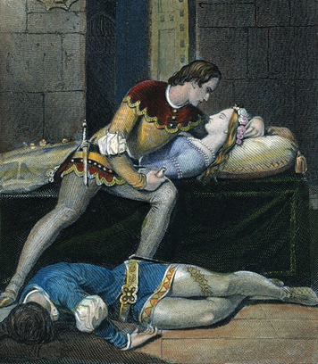
William Shakespeare (1564–1616) was born in the English town of Stratford-on-Avon. He was a major figure of the English Renaissance. He is widely considered to be the world’s greatest playwright and one of its finest poets.
Personality and Training As a boy, Shakespeare studied Latin and classical literature in grammar school. He never went to a university. His plays, however, show a broad knowledge of many subjects, from history and politics to music and art.
In his early twenties, Shakespeare became an actor with a theater company in London. He learned about drama by performing and writing plays. Many of his plays were first presented at London's Globe Theatre. Queen Elizabeth, among many others, enjoyed his work.
Shakespeare had a reputation for being quiet and a bit mysterious. His writings show that he was curious and keenly observant. He thought deeply about life and its sufferings. Yet he also had a sense of humor and found much to laugh at in life.
Talents and Achievements Shakespeare was a skilled actor, but he was an even greater poet and playwright. He had an enormous talent for expressing thoughts and feelings in memorable words. His plays show that he had a deep understanding of human behavior and emotions. Above all, he had the skill to present his understanding through vivid characters and exciting drama.
Shakespeare’s poetry is widely admired, especially the 14-line poems called sonnets. He is best known, however, for his 38 plays. He wrote both comedies and tragedies. Many of his plays are still performed around the world, and several have been made into television series or movies. Among the most popular are Romeo and Juliet, Hamlet, Macbeth, Julius Caesar, All's Well That Ends Well, and The Merchant of Venice.
Shakespeare’s plays cover a broad range of subjects. He wrote about history, romance, politics, prejudice, murder, and war. His plays remain popular in part because he wrote about timeless, universal themes such as love, jealousy, power, ambition, hatred, and fear.
Shakespeare has had a deep influence on later writers. He also left a lasting mark on the English language. Many common sayings come from Shakespeare, such as “Much ado about nothing.” People often quote his witty, wise lines, sometimes without knowing that they owe their clever or graceful words to Shakespeare.

Section 11 - Miguel Cervantes, Spanish Writer
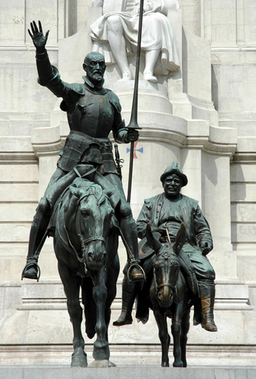
Miguel Cervantes (mi-GEL ser-VAN-tayz) was born near Madrid, Spain. He lived from 1547 to 1616. He is best known for his comic novel Don Quixote (DON kee-HOH-tay).
Personality and Training Little is known about Cervantes’ education. He may have studied with priests influenced by humanism. It is certain that he loved to read.
Much of Cervantes’ education came through experience. At 23, he became a soldier. In a battle at sea, he was shot twice in the chest. He also injured his left hand so badly that the hand became useless. Several years later, he was taken prisoner at sea by pirates. He spent five years as a slave in North Africa until his family bought his freedom.
Cervantes’ early life shows that he was adventurous and courageous. His sense of humor could be biting, but he also turned it on himself. He once bragged that the public liked his plays enough not to boo them off the stage or throw vegetables at the actors.
Talents and Achievements A gifted writer, Cervantes wrote many plays, poems, and novels. He had a particular talent for satire. His masterpiece, Don Quixote, pokes fun at romantic stories of heroic knights, as well as at Spanish society. The novel’s title character, Don Quixote, is an elderly man who has read too many tales of glorious knights. Although the age of knights is past, he dresses up in rusty armor and sets out to do noble deeds. With him is short, stout Sancho Panza. Sancho is an ordinary farmer who rides a mule, but Don Quixote sees him as his faithful squire, or armor bearer.
Together the two men have a series of comic adventures. In Don Quixote’s imagination, country inns turn into castles and windmills become fearsome giants. While his adventures are very funny, there is something noble about the way he bravely fights evil, even if his deeds are only in his mind.
Don Quixote was very popular in Spain. King Philip III supposedly saw a man reading and laughing so hard that he was crying. The king said, “That man is either crazy or he is reading Don Quixote.” Today, Don Quixote is considered one of the masterpieces of world literature.

Section 12 - Leonardo da Vinci, Renaissance Person
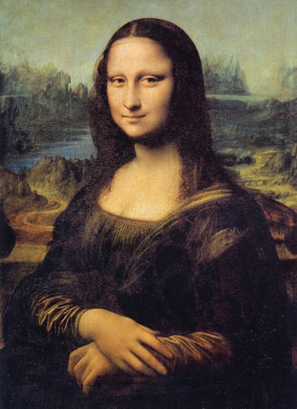
Leonardo da Vinci (1452–1519) was born in a village near Florence in Italy. His wide range of interests and accomplishments made him a true Renaissance person.
Personality and Training Leonardo trained in Florence under a master sculptor and painter. All his life he studied many subjects, including painting, sculpture, music, math, anatomy, botany, architecture, and engineering.
Leonardo spent much of his life in Florence and Milan. He worked as an artist, engineer, and architect for kings, popes, and wealthy commoners. He had a special love for animals. Sometimes he bought caged animals at the market and set them free. He also was a vegetarian, which was quite unusual at the time.
Talents and Achievements Leonardo was gifted in many fields. He was an accomplished painter, sculptor, architect, and engineer.
Leonardo’s notebooks show him to be one of the greatest creative minds of all time. Like Albrecht Dürer, he closely studied proportions. He made precise drawings of people, animals, and plants. He also sketched out ideas about geometry and mechanics, the science of motion and force. He designed weapons, buildings, and a variety of machines. Many of the inventions he imagined, such as a helicopter and a submarine, were centuries ahead of their time.
Leonardo’s paintings are among the world’s greatest works of art. One of his masterpieces is the Mona Lisa, a painting of a woman with a mysterious smile. It is among the most famous paintings in the world. Like his other works, it displays a remarkable use of perspective, balance, and detail. The rich effects of shade and color reveal Leonardo’s close study of light. Students of his art also detect how principles of geometry helped him organize the space in his paintings.
Leonardo’s work inspired other great artists, such as Michelangelo. With his many interests and talents, Leonardo is a perfect example of the spirit of the Renaissance.

Summary
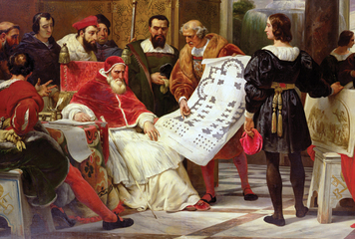
In this chapter, you learned how the Renaissance spread from Italy across Europe. Then you studied the lives and accomplishments of ten major Renaissance figures.
The Renaissance Spreads Through Europe Renaissance ideas spread through trade, travel, and education. People from across Europe went to Italy to learn and to trade. When they returned home, they passed on the new ideas. Many founded schools and universities. The spread of the Renaissance was made even easier by Gutenberg's new printing press.
Michelangelo, Titian, and Dürer Renaissance artists like Michelangelo, Titian, and Dürer created many kinds of art. They studied human anatomy and mathematics that helped them to create works of art based on humanist ideals of realism and beauty.
Copernicus and Vesalius Through observation and fresh thinking, scientists Copernicus and Vesalius dramatically increased human knowledge. Copernicus discovered that Earth and other planets in our solar system revolve around the sun, not Earth. Vesalius’ studies of anatomy and his detailed drawings changed how people understood the human body.
Isabella I and Elizabeth I Queen Isabella and Queen Elizabeth were strong leaders who supported the arts and encouraged exploration. Both monarchs improved their nations and financed important explorations that increased Europeans’ knowledge of the world.
Shakespeare and Cervantes Shakespeare and Cervantes created masterpieces of world literature. Both writers created lyrical and expressive works that explored humanist ideas and enriched their native languages.
Leonardo da Vinci Leonardo da Vinci was a creative genius who embodied the spirit of the Renaissance. His studies in topics such as art, architecture, and engineering led him to invent many devices that were far ahead of his time, as well as timeless works of art.

Reading Further - From Gutenberg to the Internet
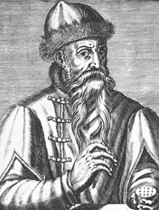
Around 1450, Johannes Gutenberg invented a printing press that used movable metal type. Before Gutenberg’s press, books and other printed materials were made by hand. Printed material was costly to make and to buy. Gutenberg’s invention changed Europe by making books more affordable and by spreading information faster and to more people. Today, Gutenberg is known as the inventor of printing in Europe. But his achievements were hard won—and his invention was almost taken away from him.
The year is 1455, and Johannes Gutenberg sits in a courtroom. Across from him is Johann Fust, who has sued Gutenberg. The two men are bitter enemies. Gutenberg shifts nervously, waiting for the judges’ decision. If the judges rule against him, he will lose everything—including the printing press that he has worked for 20 years to perfect.
Gutenberg was born in Mainz, Germany, sometime between 1394 and 1400. He found, at a young age, that he loved to work with metal. He worked with craftsmen in the city and slowly learned their secrets. He showed an extraordinary talent, mastering the technology of turning metal into beautiful objects. He was also fired with the ambition to do something special that people would remember.
In 1428, Gutenberg moved from Mainz to Strasbourg. He started a business cutting gemstones to make jewelry. The company thrived, and he formed a business partnership with three other men. Soon they were making mirrors and other quality products.

Early Printing and Movable Type
During the 1430s, Gutenberg saw the chance to do something even greater—to develop a printing press that lowered the cost of books. Printing was first developed in China and Japan in the 8th century. Craftspeople in those countries spent hours carving an image into a block of wood. They rolled ink onto the raised parts and pressed the image against paper.
Korean craftspeople were the first to develop metal movable type, in which the characters could be rearranged to form different words. During the 13th century, they formed type by heating bronze to a temperature high enough to make it liquid. They poured the bronze into molds formed in sand, and the bronze hardened and formed type. They then used the type to form all the words on a page, applied ink to the type, and rubbed paper against it, producing a printed page.
In 1377, the Koreans printed a text for Buddhists. It is the oldest known book in the world printed with movable metal type.
Europeans did not develop movable type for another 200 years. Until then, monks and nuns in monasteries painstakingly copied books by hand. Many of the books were unique works of art. They had huge, colorful capital letters, complex illustrations, and the edge of each page was lined with gold. But these books were incredibly expensive. A person had to work an average of 300 days to make just one book. Historians estimate that the typical book might cost between $200 and $250 in today’s dollars. Only the very wealthy could afford such items.
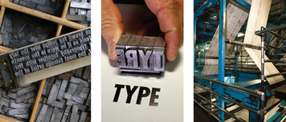

Inventing Type, a Press, and Ink
Gutenberg turned his creative genius to developing a way to print books that would cost far less money. He faced three challenges—developing type, creating a printing press, and mixing the right ink. To create type, he had to decide what metal to use. It couldn’t be too hard because then it wouldn’t melt. It couldn’t be too soft because then the type wouldn’t last. Finally, he hit on a brilliant idea. Instead of one metal, he would blend different metals. He created an alloy—or combination of metals—which included 80 percent lead, 5 percent tin, and 15 percent of a metal called antimony.
To make the letter a, for example, he heated the metal until it melted, poured it into a mold, let it cool, and then removed the metal from the mold. Now he had the type for the letter a, which he could use over and over again. He did the same for all the other letters and for punctuation.
Next, Gutenberg needed to find the right ink. It couldn’t be too thin, because then it would leave smudges on the paper. It couldn’t be too thick, or it would clog the type. Gutenberg experimented for a long time and finally used linseed oil. To make it black, he added soot, which he got from lamps.
Finally, Gutenberg had to build a press. Historians believe that he probably adapted a press that papermakers used to dry stacks of paper. In his press, Gutenberg set the type and rolled ink onto the type. Then he turned a giant screw that lowered the type onto paper. In a few seconds, he could print a page that would have taken a monk hours to copy. More importantly, he could make many copies of the same page very quickly.
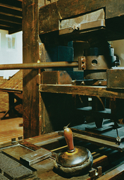

Printing Success and Business Setbacks
Gutenberg made great progress on the printing press, but he faced some serious business problems. First, one of his partners died. Then the man’s relatives sued Gutenberg to get control of the business. Gutenberg was relieved when the court ruled in his favor. But even though he won, the lawsuit kept him from finishing his printing press.
Gutenberg’s problems got worse. He ignored the jewelry business, and his income sank. Yet he was spending money to buy metals, a press, and inks. He went into debt, but he kept working on the printing press. Finally, in 1446, he had his first major triumph, when he printed a short poem. Soon after, he printed a grammar book. It became a bestseller throughout Europe.
These early books were plain, and Gutenberg wanted to print something wonderfully beautiful. Money was still a big problem. So Gutenberg formed a partnership with Johann Fust, a wealthy businessman in Mainz. Fust loaned him 1,600 guldens, which at that time was a fortune. Historians have estimated that just 100 guldens could buy a small farm. The two men planned to print a book that would sell extremely well and give them a good return on their investment. But what kind of a book should it be?
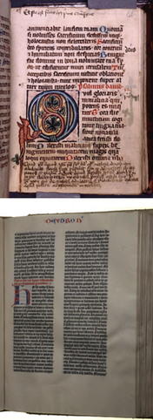

Printing a Bible
Finally they came up with a brilliant idea—they would print a Bible that was extraordinary in every way. Around 1455, Gutenberg started preparations. The Bible would have two volumes: the Old Testament and the New Testament. It would have 42 lines per page, and the two volumes together would contain 1,282 pages. Every page would have 2,000 letters. For this monumental task, Gutenberg had to create 290 pieces of type, including capital letters, lower case letters, and punctuation. He planned to print 210 copies.
While Gutenberg was aiming for perfection, Fust was growing impatient. He had invested 1,600 guldens in the printing press, but in five years, the investment had not earned him one penny. He filed a lawsuit against Gutenberg, demanding that his money be returned. Gutenberg simply didn’t have the money. He desperately needed the judges to find in his favor.
But the judges ruled against Gutenberg. They said that Fust had waited long enough to earn a profit on the money that he had invested. Gutenberg had to repay Fust. Since Gutenberg didn’t have the funds, the court allowed Fust to take over the business, including the typefaces and the printing press. Fust even hired away Gutenberg’s most skilled assistant. Together, they finished work on the Bible that Gutenberg had started and began to sell it. This remarkable book became an instant bestseller. Fust made a good deal of money from the sweat, tears, and genius that Gutenberg had poured into the project.
Yet Gutenberg was an amazingly stubborn man. Fust had taken away his business, but he couldn’t take away Gutenberg’s knowledge and skills. He found another financial backer, Dr. Konrad Humery, who helped him set up a printing shop in Mainz. Gutenberg printed philosophical writings, a dictionary, and other works, all with the extraordinary quality that was his trademark. He also trained printers, who spread his printing technology throughout Europe.

Books: The Internet of the Time
Gutenberg’s amazing invention made books the Internet of the time. The printing press made it possible to produce books much more quickly and cheaply than ever before. By 1463, printed Bibles cost one-tenth of hand-copied Bibles. The demand for books exploded. By 1500, Europe had more than 1,000 printers and 7,000 books in print.
Like the Internet, books spread new ideas quickly and sped up the process of change. For example, as a young sailor in Genoa, Christopher Columbus read Marco Polo’s famous Travels, in which he described his journeys to China. Columbus was thrilled by Polo’s descriptions. Books also planted the seeds of democracy and human rights in the next generation of thinkers. Newspapers and pamphlets generated information and ideas even faster.
In 1465, the Archbishop of Mainz gave Gutenberg a pension for the “agreeable and willing service” that he had provided to the city and to Germany. Gutenberg died in 1468, and Dr. Humery inherited everything. Yet the Archbishop refused to let the doctor move Gutenberg’s printing press. The city was honored to be the birthplace of printing in Europe. Gutenberg would always be known as the father of an invention that truly changed the world.

