9. Elizabeth I, Queen of England
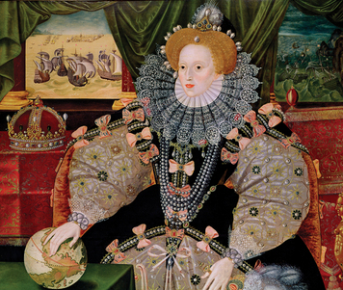
Queen Elizabeth I (1533–1603) was one of England’s most popular and successful monarchs. Born in London, she was the daughter of King Henry VIII and his queen at the time, Anne Boleyn.
Personality and Training When Elizabeth was two years old, King Henry lost interest in Queen Anne. Claiming that Anne had been unfaithful to him, he ordered her beheading.
Elizabeth was raised in a separate household, largely away from the royal court. An English scholar became her teacher and educated her as a possible future monarch. Elizabeth was a gifted student. She became highly educated and learned to speak Greek, Latin, French, and Italian.
Elizabeth was a strong-minded ruler, but she was not stubborn. As monarch, she was willing to listen to good advice and always kept in mind what was best for the people of England.
Talents and Achievements Elizabeth became queen at age 25 and reigned for 45 years, until her death. She never married, because she feared that a husband would take her power. She said she was married to the people of England.
Elizabeth was a hard-working and able ruler. She was independent, but she was also flexible. She was willing to change unpopular policies. She showed political skill in balancing the interests of different people in her court. She inspired great love and loyalty from her subjects, who called her “Good Queen Bess.”
Elizabeth’s long reign is often called England’s Golden Age. Culture thrived under her rule. She supported theater, fashion, literature, dance, and education. Poets and playwrights during her rule composed some of the greatest works in the English language.
Elizabeth worked to strengthen England’s economy, and she encouraged trade and commerce. She authorized English trading companies in Africa, Asia, and the Americas. Her funding of sea exploration helped England gain territory in North America. In 1588, the English navy defeated the Spanish Armada, a mighty fleet that tried to attack England. This victory sparked a national celebration and further strengthened England’s sea power. By the time Elizabeth died, England was one of the strongest and richest countries in the world.

