8. Isabella I, Queen of Spain
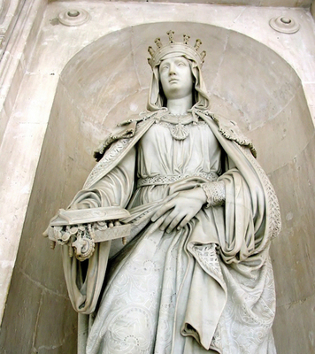
Queen Isabella I (1451–1504) was born in the Spanish kingdom of Castile. She is best known for creating a unified Spain and for sponsoring the voyages of Christopher Columbus.
Personality and Training Isabella was the daughter of the king of Castile. She was highly intelligent, strong-willed, and a devoted Catholic. Girls at that time received little education, so Isabella’s schooling was limited. In adulthood, she educated herself by learning Latin. As queen, she supported scholarship and art, collected fine paintings, and built schools.
Talents and Achievements Isabella was a forceful and brave ruler. In 1469, she married Prince Ferdinand of Aragon, the other major kingdom in Spain at that time. In 1474, Isabella became queen of Castile. When Ferdinand inherited the throne of Aragon in 1479, the two monarchs ruled jointly over much of Spain. They fought several battles to unify the rest of the nation.
Isabella and Ferdinand actively encouraged exploration. Isabella gave her support to Christopher Columbus, an Italian who proposed finding a new sea route to Asia. In 1492, Columbus sailed across the Atlantic and stumbled upon the Americas. His discovery of this so-called New World would lead to a Spanish empire and create great wealth for Spain.
Isabella and Ferdinand also sought to strengthen Spain as a unified Catholic country. Jews who refused to convert to Catholicism were forced to leave. This harsh action cost Spain many of its most talented and productive citizens. For Spanish Jews, it was a tragedy.

