Section 12 - Leonardo da Vinci, Renaissance Person
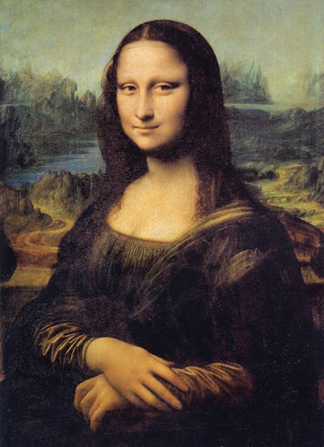
Leonardo da Vinci (1452–1519) was born in a village near Florence in Italy. His wide range of interests and accomplishments made him a true Renaissance person.
Personality and Training Leonardo trained in Florence under a master sculptor and painter. All his life he studied many subjects, including painting, sculpture, music, math, anatomy, botany, architecture, and engineering.
Leonardo spent much of his life in Florence and Milan. He worked as an artist, engineer, and architect for kings, popes, and wealthy commoners. He had a special love for animals. Sometimes he bought caged animals at the market and set them free. He also was a vegetarian, which was quite unusual at the time.
Talents and Achievements Leonardo was gifted in many fields. He was an accomplished painter, sculptor, architect, and engineer.
Leonardo’s notebooks show him to be one of the greatest creative minds of all time. Like Albrecht Dürer, he closely studied proportions. He made precise drawings of people, animals, and plants. He also sketched out ideas about geometry and mechanics, the science of motion and force. He designed weapons, buildings, and a variety of machines. Many of the inventions he imagined, such as a helicopter and a submarine, were centuries ahead of their time.
Leonardo’s paintings are among the world’s greatest works of art. One of his masterpieces is the Mona Lisa, a painting of a woman with a mysterious smile. It is among the most famous paintings in the world. Like his other works, it displays a remarkable use of perspective, balance, and detail. The rich effects of shade and color reveal Leonardo’s close study of light. Students of his art also detect how principles of geometry helped him organize the space in his paintings.
Leonardo’s work inspired other great artists, such as Michelangelo. With his many interests and talents, Leonardo is a perfect example of the spirit of the Renaissance.

