3. Michelangelo, Italian Sculptor and Painter
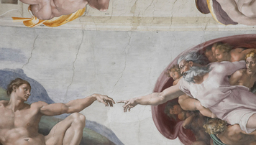
Michelangelo (1475–1564) was one of the leading artists of the Renaissance. He was born in a small village near Florence and grew up to be one of the greatest painters and sculptors in history.
Personality and Training Historians say that Michelangelo had a difficult childhood. His mother died when he was six years old. His father was stern and demanding. Perhaps this troubled early life contributed to Michelangelo’s famously bad temper. Although he was very religious, he was known to use fierce words when he was angry. He was also intensely ambitious.
When Michelangelo was 13, he became an apprentice to a painter in Florence. At 15, he began studying with a sculptor who worked for the powerful Medici family. Michelangelo lived for a time in the Medici household. There he met many leading thinkers, artists, and writers.
Talents and Achievements Michelangelo was gifted in both sculpture and painting. His art combines Renaissance ideals of beauty with emotional expressiveness.
Michelangelo’s sculptures show his amazing talent for carving lifelike figures from blocks of marble. When he was just 24, he carved his famous La Pietà. A pietà is a depiction of Mary, the mother of Jesus, mourning over her dead son. Michelangelo’s Pietà shows Mary tenderly holding the body of Jesus across her lap.
Two other magnificent sculptures by Michelangelo are his David and Moses. Michelangelo’s David is 17 feet tall. The statue combines great beauty with the intense look of a youth who is about to go into battle. Michelangelo’s Moses is a strong, powerful figure. The statue shows Moses holding the Ten Commandments, which the Bible tells he received from God.
Michelangelo is perhaps best known for painting the ceiling of the Sistine Chapel, the pope’s chapel in Rome. Michelangelo labored for almost four years on a high platform to complete this work. He covered the curved ceiling with brilliantly colored scenes from the Bible. The scenes contain over three hundred figures and continue to awe visitors to Rome today.

