4. Titian, Italian Painter
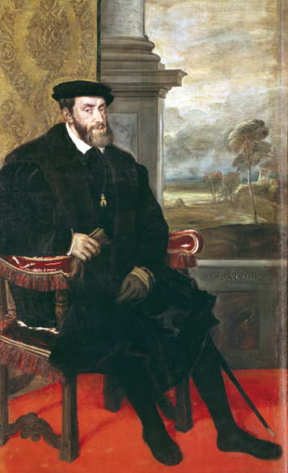
Titian (TISH-uhn), who lived from about 1488 to 1576, was born in the Italian Alps. Early in life, his talent took him to the wealthy city-state of Venice. He became the city’s greatest Renaissance painter.
Personality and Training As a boy, Titian was sent to Venice to train with famous painters. He worked with an artist named Giorgione, who was a master of fresco painting. A fresco is a painting made on the wet plaster of a wall or ceiling. Titian also studied examples of art from Rome and Florence. In time, he outgrew the influence of his teachers and created his own style. Titian was a persuasive man. According to legend, long after he was rich and famous, he persuaded patrons to support his art by claiming to be poor. But he was also quite generous with his friends.
Talents and Achievements Titian’s early work was precise and detailed. Later he developed a freer style. He used blobs of paint to create vivid forms, colors, and textures. He was known for his inspired use of color and for loose, lively brushwork that made his pictures appear lifelike. His art also had a flair for expressing human personality.
Titian painted many scenes of classical myths and Bible stories. As a court painter, he created portraits of the rich and powerful. In 1516, he was named the official painter of Venice. Later, Holy Roman emperor Charles V made him court painter of Italy. Titian made many portraits of Charles V and other royalty. Charles V greatly admired Titian’s work. There is a story that the emperor once picked up a paintbrush that had fallen to the floor. Titian protested, “I am not worthy of such a servant.” The emperor replied, “Titian is worthy to be served by Caesar,” referring to the emperor of ancient Rome. Charles even made Titian a knight—a first-time honor for a painter.

