7. Andreas Vesalius, Belgian Scientist
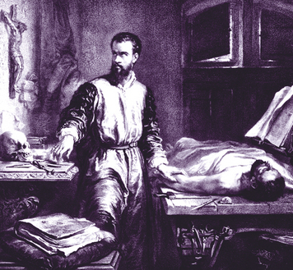
Andreas Vesalius (1514–1564) was born in Brussels, in what is now Belgium. He became an outstanding scientist. His work changed medicine and the study of anatomy.
Personality and Training Vesalius came from a family of doctors and pharmacists. Pharmacists are people who prepare medicines. He was always interested in living things and, especially, in anatomy.
Vesalius attended universities in Flanders, France, and Italy. In 1537, he earned his medical degree, specializing in anatomy. Later, he became a personal doctor to Italian and Spanish royalty.
Vesalius was hardworking, curious, and confident. He was also said to be gloomy and distant at times.
Talents and Achievements Vesalius was a talented observer and an independent thinker. He also had the artistic skill necessary to make detailed drawings of his scientific observations.
In Vesalius’s time, physicians’ understanding of human anatomy was based on the works of the ancient Greek physician Galen. Vesalius studied Galen, but he soon broke with this tradition. Like Copernicus, he was determined to observe things for himself.
Vesalius began dissecting, or cutting apart to study, dead human bodies. His research showed that Galen’s work had relied on studies of animals. As a result, it had many errors when applied to human anatomy and medicine.
Vesalius made many discoveries about the human body. For example, he showed that the human heart has four hollow areas, called chambers. His discoveries led him to write his own seven-volume textbook of anatomy.
Vesalius called his book On the Structure of the Human Body. It explains how the body functions. The book contains prints by artists that were based on Vesalius’s drawings of the body.
Vesalius’s book was a major breakthrough. It changed what people knew about human anatomy and how they studied it. It also changed physicians’ understanding of medicine. His book is considered to be the world’s first modern medical textbook.

