Vocabulary Terms
Word | Meaning | Image/Sentence
Containment

Decolonization

Demilitarization

Displaced

Infrastructure

Negotiation

Partition

Refugee

Homeland

Important terms
- Iron curtain-________________________________________________________________________________________________________________________________________________
- Mutually assured distruction-________________________________________________________________________________________________________________________________________________
- Great Leap Forward-________________________________________________________________________________________________________________________________________________
- Cultural Revolution-________________________________________________________________________________________________________________________________________________
- Arms Race-________________________________________________________________________________________________________________________________________________
United Nation
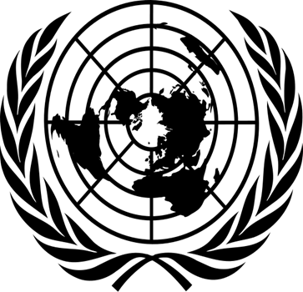

The United Nations is an international peacekeeping organization created at the end of World War II. It gives all the nation in the world a place to meet and discuss problems.

The United Nations replaced the League of Nations that was created after WW I. That organization was unable to prevent World War II, and stopped meeting. America never joined the League of Nations, but took the lead in creating a new organization.
1. How many countries are currently members of the United Nations? Which countries founded the organization? ___________________
________________________________________________________
2. Which city is the headquarters at? _________________________________________________________
3. What is the main goal of the United Nations? __________________________________________________________

