Name:_______________ The Scramble for Africa WEBquest
PART ONE: Imperialism
1. Africa is an enormous continent with hundreds of different cultural and linguistic groups. It is three times larger than Europe.
2. Europeans consistently asserted their control of Africans through construction of racist mentalities and practices, severely damaging the traditions and political structures of the African people.
3. Whenever possible, Africans resisted European oppression, culminating in the Nationalist movements of the late 20th century.
1. What led to the "Scramble for Africa"?
___________________________________________________________________________________
2. Which European Countries controlled the most land in Africa?
____________________________________________________________________________________
3. Who led the British Imperialism in Africa?
____________________________________________________________________________________
4 Which African countries were left independent at the time of World War 1?
____________________________________________________________________________________
A. The Berlin Conference _____________________

1. List 3 reasons why Europeans wanted to take over Africa.

2. What was the Berlin Conference?

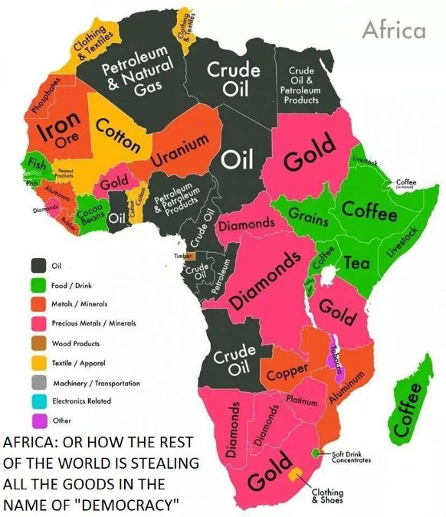

3. What agreements came out of the Berlin Conference? (Summarize in a few words Articles 34 and 35)

4. What considerations were made by the Europeans to native Africans?

5. Make a Guess: How will the decisions made at the conference change Africa?
B. The “Scramble for Africa”
Make a Guess: What is the Scramble for Africa?

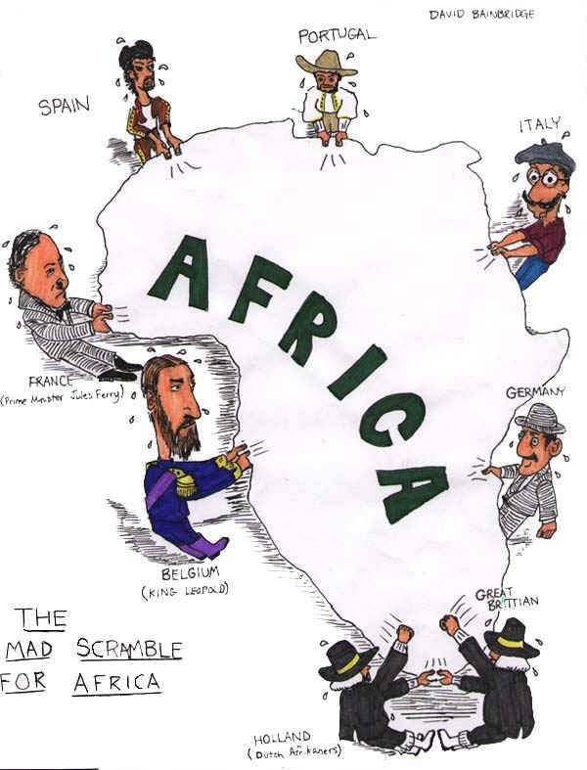

Answer the Questions based on the “scramble for Africa” Cartoon
1. According to the cartoon, which European countries were fighting for a position in Africa?

2. Make a prediction: How did the Berlin Conference lead to the situation shown in this cartoon?

C. Examine the maps:
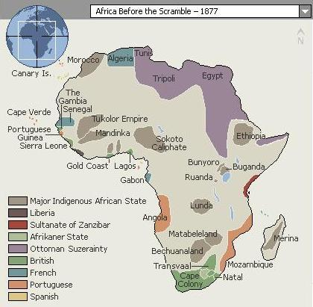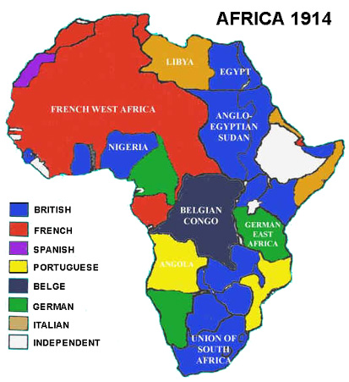
1. What is the main difference between the two maps?

2. What part did the Berlin conference play in the creation of Map 2?
The Berlin Conference of 1884-1885.

3. What happened to the native political entities by 1914? 4. According to Map 2, which European countries held the most territory?

PART TWO: Use the map below 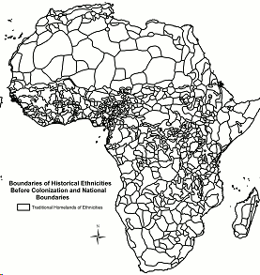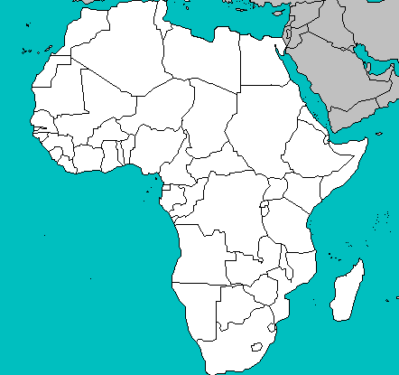
Background information: According to the key, the light black lines show tribal boundaries in Africa before European colonization. The bold black lines show the country boundary lines that exist today that were helped shaped by the Europeans. Before European colonization, tribal boundaries were used to separate territories in Africa.

1. Explain what happened to tribes when the Europeans made these new borders.

2. Using your answer for number 1, was this a good or bad thing? Explain why

Part Three:Now…..PUT IT ALL TOGETHER AND ASNWER THE FOLLOWING:
1. How did European colonization and partitioning of Africa lead to present day conflicts and civil war?

